CYBER SECURITY TASK 01
Part A: Device Security Assessment

System Security · OS Version · Updates · Antivirus · Firewall

Submitted By
Pratiksha Vishwakarma
Internship Cybersecurity Task · Personal Security Audit & Cyber Awareness Assessment

Security Assessment Overview

This report presents a comprehensive security assessment of a personal HP laptop. The following parameters were evaluated as required: operating system version, system update status, antivirus installation, and firewall configuration. All findings are supported by screenshots captured during the assessment.

Security Parameter | Status | Findings
Operating System | ✔ Identified | Windows 11 Home Single Language — Version 25H2, Build 26200.8655
Is the system updated? | ✔ YES | Fully up to date — 4 security hotfixes applied
Antivirus Installed? | ✔ YES | Windows Defender — Active, real-time protection ON, 0 threats
Firewall Enabled? | ✔ YES | Firewall ON across all 3 profiles: Domain, Private, Public

1. Operating System Version

The winver command was executed from the Windows Run dialog (Win + R) to identify the exact operating system version and build number. Results confirm the device is running Windows 11 Home Single Language, Version 25H2, OS Build 26200.8655.

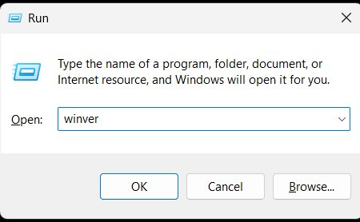
Figure 1.1 — Windows Run dialog with 'winver' command entered
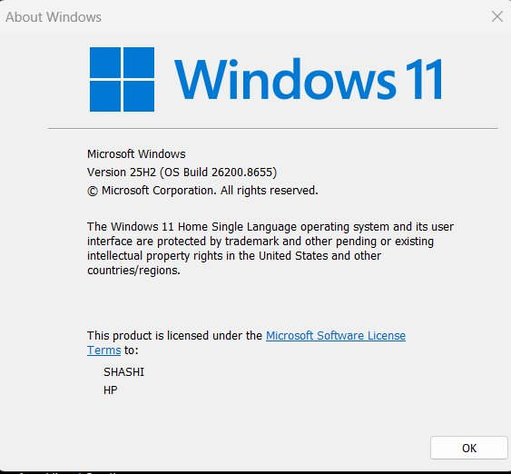
Figure 1.2 — About Windows: Version 25H2, OS Build 26200.8655 — Licensed to SHASHI / HP

Field | Details
Operating System | Microsoft Windows 11 Home Single Language
Version | 25H2
OS Build Number | 26200.8655 (Kernel: 10.0.26200)
System Type | x64-based PC
Registered To | SHASHI / HP

✔ OS Version confirmed: Windows 11 Home — Version 25H2, Build 26200.8655

2. Detailed System Information

The systeminfo command was executed in Command Prompt to retrieve a complete inventory of hardware specifications, installed hotfixes, network configuration, and active security features.

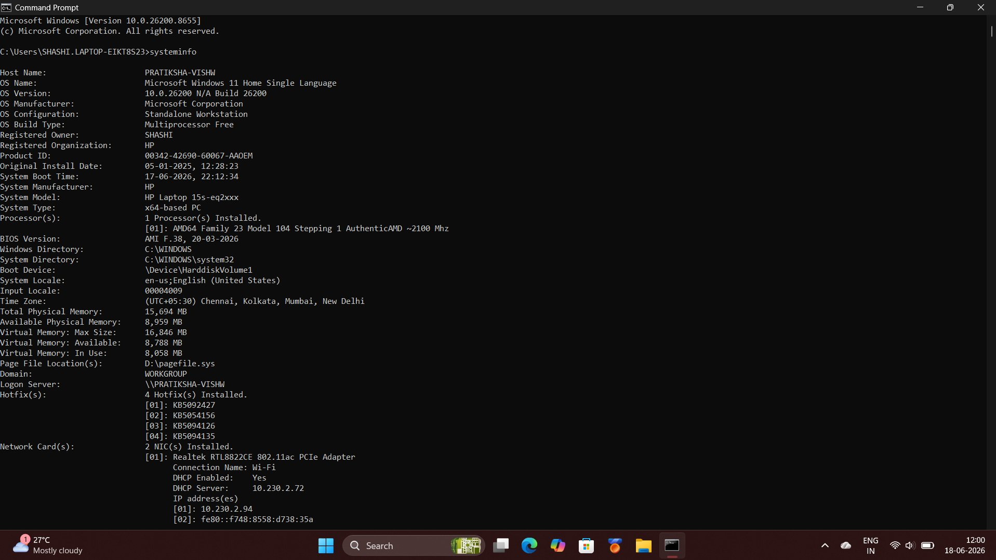
Figure 2.1 — systeminfo output (Part 1): OS details, processor, memory, BIOS version, 4 hotfixes installed
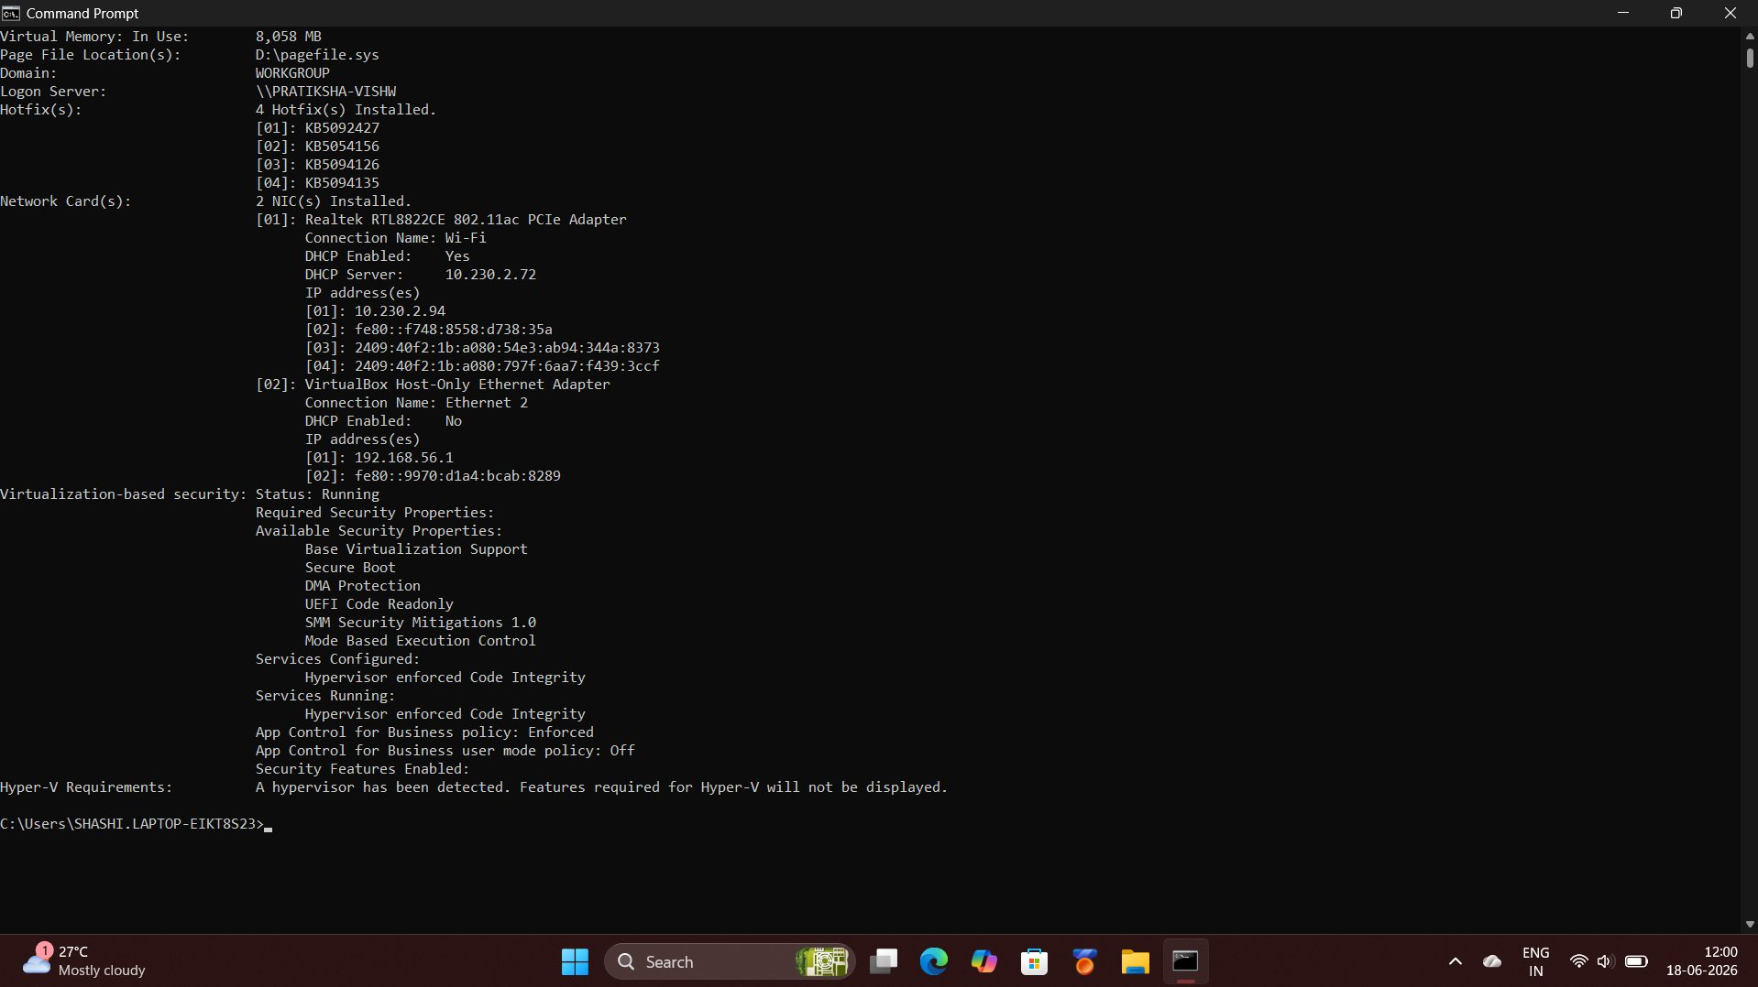
Figure 2.2 — systeminfo output (Part 2): Network adapters and virtualization-based security features

Field | Details
Host Name | PRATIKSHA-VISHW
Device Manufacturer | HP
Device Model | HP Laptop 15s-eq2xxx
Processor | AMD64 Family 23 Model 104, AuthenticAMD ~2100 MHz
Total Physical Memory | 15,694 MB (~16 GB RAM)
BIOS Version | AMI F.38 — 20-03-2026
Hotfixes Installed | 4 installed: KB5092427 | KB5054156 | KB5094126 | KB5094135
Virtualization Security | Running — Secure Boot, DMA Protection, Hypervisor Code Integrity: Active
App Control Policy | Enforced (Business Policy)

3. Windows Update Status

The Windows Update page was verified via Settings → Windows Update. The screenshot below confirms the system has no pending updates and is configured to receive updates automatically as soon as they become available.

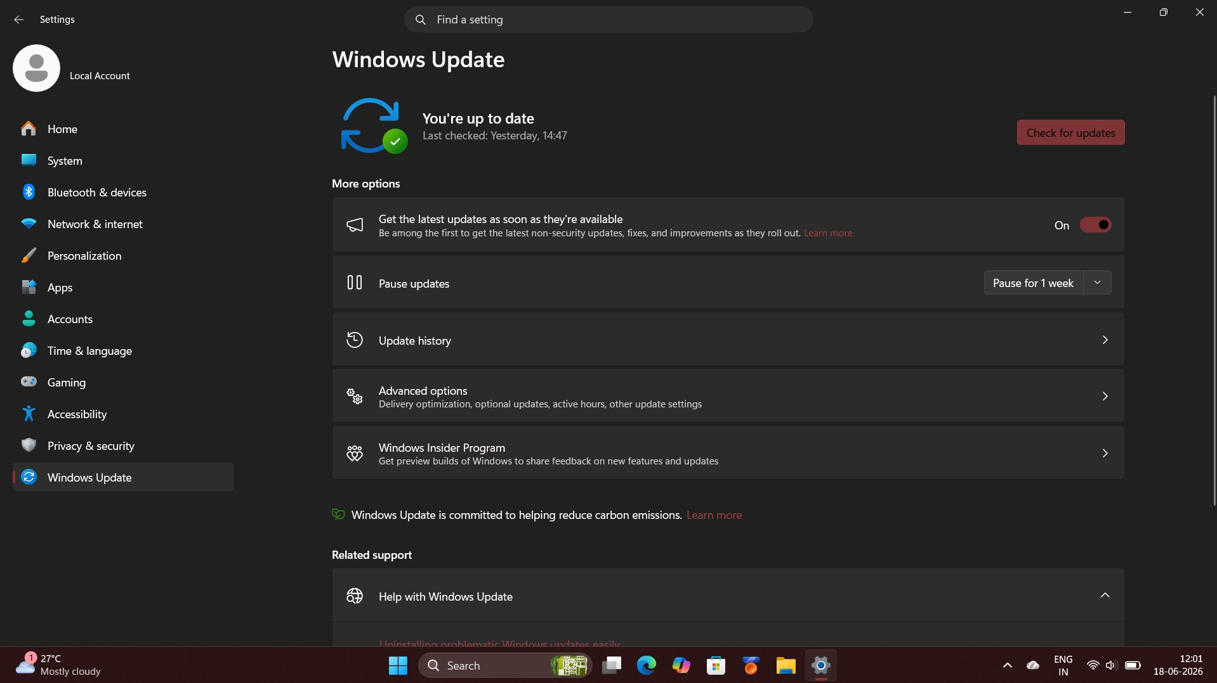
Figure 3.1 — Windows Update: 'You're up to date' — auto-update enabled, last verified yesterday at 14:47

Field | Details
Update Status | You're up to date — no pending updates
Last Verified | Yesterday at 14:47
Auto-Update | ON — receive latest updates as soon as available
Hotfixes Applied | KB5092427 | KB5054156 | KB5094126 | KB5094135

✔ Is the system updated? YES — Fully up to date. All security patches have been applied.

4. Antivirus Protection

Antivirus status was verified using three independent methods: (a) the Windows Security dashboard overview, (b) the Virus & Threat Protection detail page showing scan results, and (c) a direct WinDefend service status query via Administrator Command Prompt using the command: sc query WinDefend.

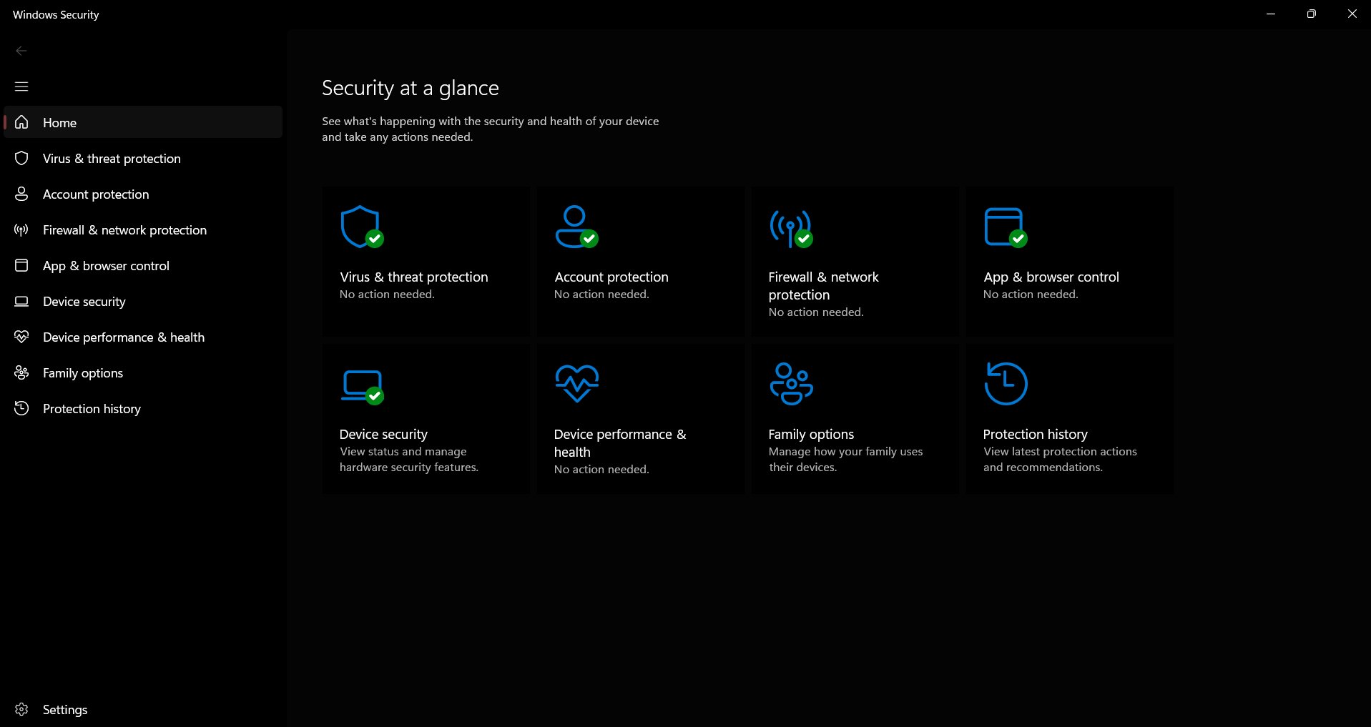
Figure 4.1 — Windows Security dashboard: All 6 protection components are active — no action needed
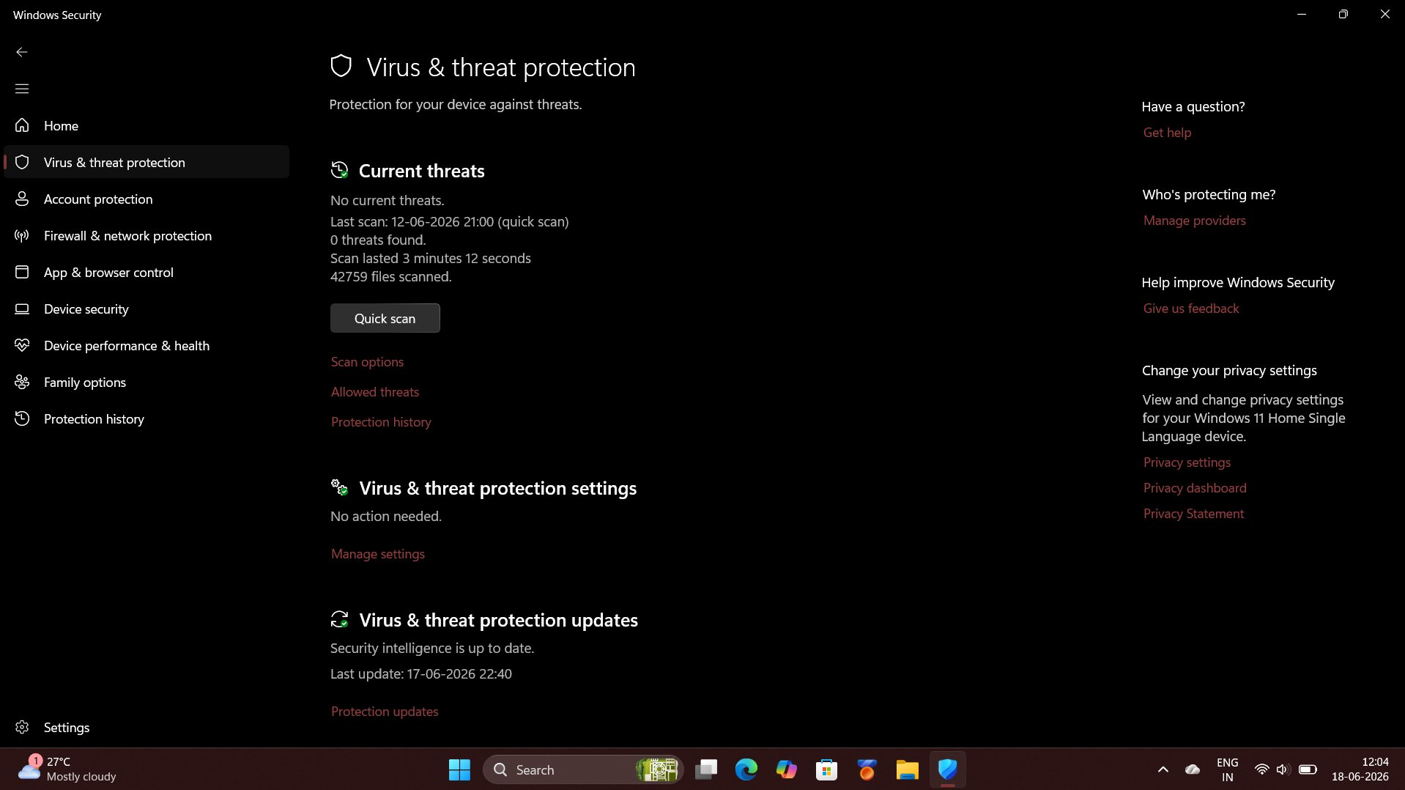
Figure 4.2 — Virus & Threat Protection: No current threats — quick scan on 12-06-2026 scanned 42,759 files, found 0 threats
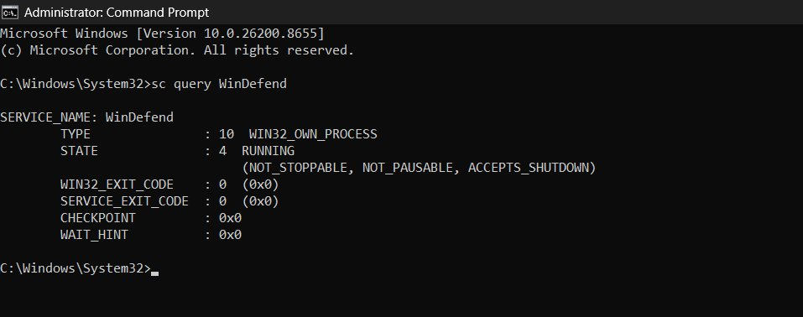
Figure 4.3 — Administrator CMD: WinDefend service STATE = 4 RUNNING (NOT_STOPPABLE, NOT_PAUSABLE, ACCEPTS_SHUTDOWN)

Field | Details
Antivirus Installed | YES — Microsoft Defender Antivirus (Windows Defender)
Service State | RUNNING — State 4 (NOT_STOPPABLE, NOT_PAUSABLE, ACCEPTS_SHUTDOWN)
Current Threats | None — No threats currently detected
Last Scan | 12-06-2026 at 21:00 — Quick Scan — 42,759 files scanned — 0 threats found
Security Intelligence | Up to date — Last updated: 17-06-2026 at 22:40
Real-Time Protection | Active — Virus & Threat Protection settings: No action needed

✔ Antivirus Installed: YES — Windows Defender is active, current, and reports zero threats.

5. Firewall Status

Windows Firewall status was verified using two independent methods: (a) the Windows Security Firewall & network protection interface, and (b) the Administrator Command Prompt command: netsh advfirewall show allprofiles — confirming the firewall state for all three network profiles.

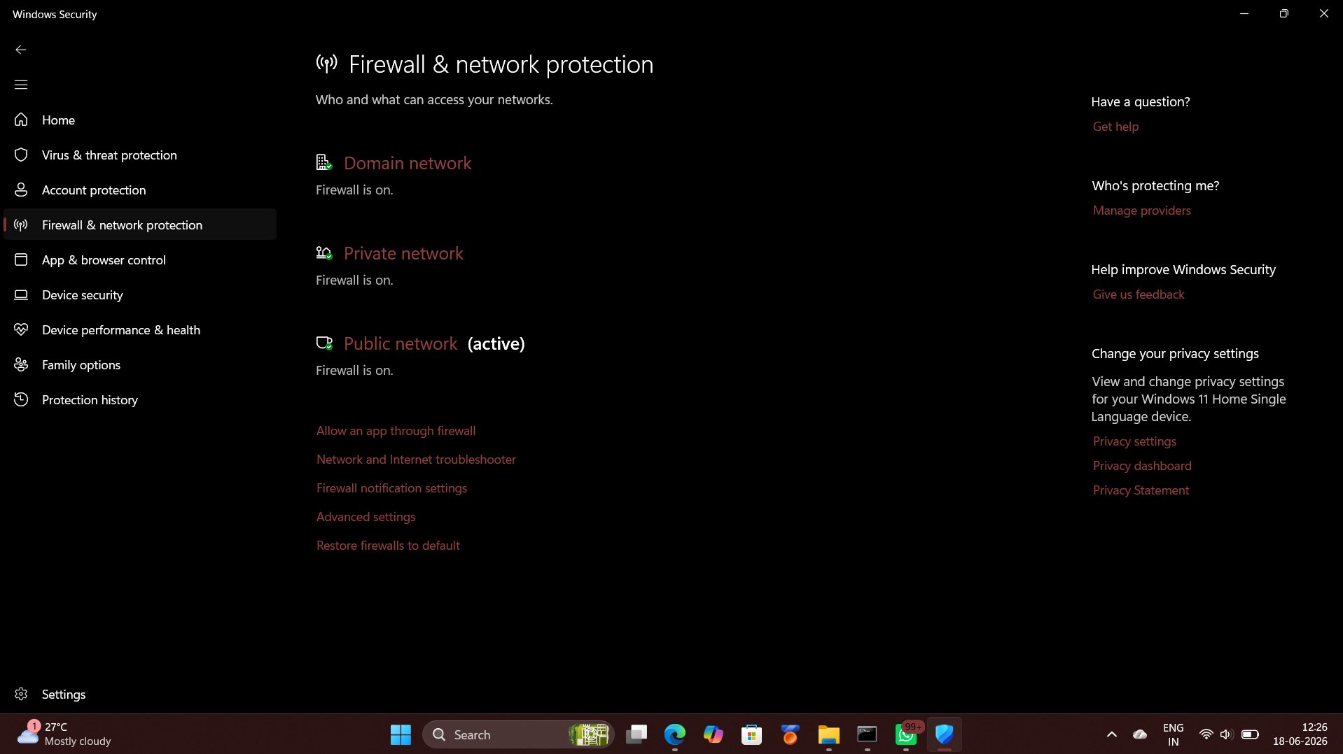
Figure 5.1 — Windows Security: Firewall is ON for Domain network, Private network, and Public network (currently active)
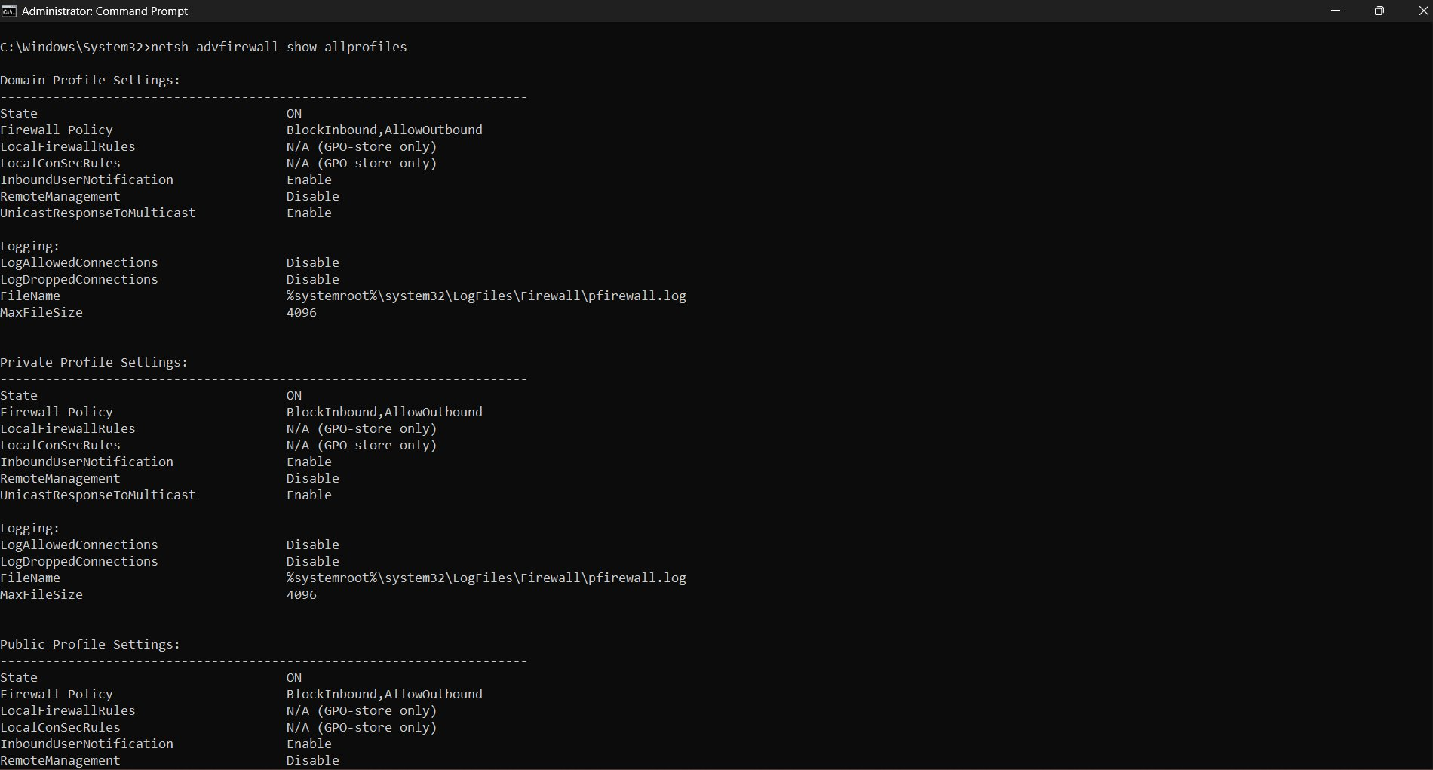
Figure 5.2 — netsh advfirewall output: Domain Profile State = ON, Private Profile State = ON, Public Profile State = ON
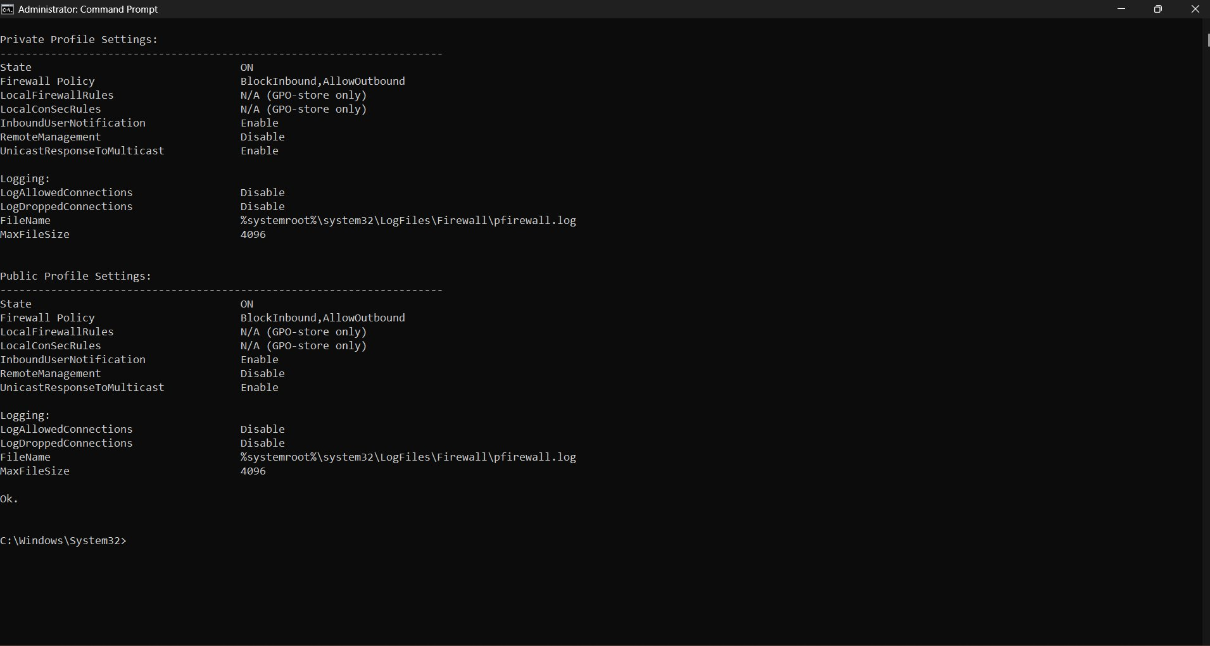
Figure 5.3 — netsh advfirewall (continued): All three profiles — Policy: BlockInbound / AllowOutbound — confirmed

Network Profile | Firewall State | Inbound Policy | Outbound Policy
Domain Network | ✔ ON | Block Inbound | Allow Outbound
Private Network | ✔ ON | Block Inbound | Allow Outbound
Public Network (Active) | ✔ ON | Block Inbound | Allow Outbound

✔ Firewall Enabled: YES — Active and enforced across all three network profiles (Domain, Private, Public).

Cyber Security Task 01 · Part A: Device Security Assessment · Pratiksha Vishwakarma · HP Laptop 15s-eq2xxx | Windows 11 Home v25H2

